Table of Contents

Medieval Artisan Guilds 4

Industrial Revolution and the Separation of Conception from Execution 4

Resistance Movements: Luddites and Arts & Crafts 5

Contemporary Digital Workflows 7

Mapping Agency: From Unified to Fragmented Control 8

Unified Agency: The Craftsperson’s Integrated Practice 8

Distributed Agency: Industrial and Digital Fragmentation 9

The Loss of Adaptive Authority 10

Towards Alternative Configurations 11

Reclaiming Agency Within Technological Constraints 11

The Access Paradigm and Its Achievements 12

The Preservation Problem: What Access Cannot Address 15

Redefining Democratization: Process Over Access 16

Deconstructing "Democratization": What Democracy Actually Requires 17

The Representation Problem in Fabrication Democracy 18

Participatory Democracy and Making 19

Deconstructing "Preservation": Beyond Cultural Heritage Models 19

Preservation as Dynamic Process vs. Static Conservation 19

Cross-Cultural Models of Adaptive Preservation 20

Documentation as Process Preservation 22

Educational Documentation: Capturing Learning Processes 22

Workflows as Narrative Preservation 23

The Limits of Algorithmic Preservation 23

Testing the Limits of preservation. AI.RTISANSHIP 23

Technical Developement: Digitizing Embodied Knowledge 24

The "Unmeasurable" Dimensions of Knowledge 24

Implications for Digital Fabrication Preservation 25

Beyond Documentation: Toward Ecological Preservation 25

*CR3ATED*: Reimagining CAD Interfaces for Artisan Expression 27

Exploring Alternative Interface Approaches 27

Craftinnova: Testing Alternative Interfaces 28

Material Continuity and Digital Mediation 28

Expanding vs. Replacing Practice 29

AI.RTISANSHIP Technical Documentation 30

Workshop Materials and Protocols 30

Software Implementation Details 30

Extended Bibliography 30

**Abstract**

Digital fabrication technologies have democratized access to production tools while perpetuating the industrial era separation between design conception and material execution. This division, which has historically diminished artisanship by fragmenting holistic creative processes, continues to manifest itself in contemporary CAD/CAM workflows that benefit computational precision over embodied knowledge and tacit decision-making central to craftship, often reducing creation to pure geometry, failing to preserve the material relationships and adaptive responses that characterize traditional making practices.

This research challenges the assumption that fabrication democratization is achieved solely through access to scaled-down industrial tools and instead, looks out to do a reimagination of the relationship between maker, material, and technology, seeking to restore the holistic nature of creative practice within digital contexts, addressing how to preserve creative agency, embodied knowledge, and capacity for personal expression in digital fabrication contexts.

Through experimental tool testing and digital fabrication workshops with artisans and makers, this research develops *Ars Post Faber*, an open-source Grasshopper plug-in within the Rhinoceros CAD environment that approaches thinking and making as an integrated practice. The plug-in implements utilities designed to facilitate fluid Human-Software-Machine interactions, looking to enable embodied expression, contextual adaptation, and tacit knowledge to flow throughout the making process. Rather than abstracting away the creative journey, this approach looks to preserve the complete narrative of creation, including modifications, errors, and decision points, as integral components of the final work.

By attempting to bridge the gap between digital design and material execution, this research looks to contribute to evolving discussions around craft, technology, and creative agency in the digital age, suggesting that true democratization might require representational frameworks that honor the complexity and continuity of human creative processes.

**Keywords:** craftship, digital fabrication, human-machine interactions, preservation, democratization, artisanship

**Chapter 1: From Medieval Workshops to Digital Fabrication**

The transformation of making practices from medieval workshops to contemporary fabrication methods represents a reconfiguration of how creative decisions flow through productive and creative processes. A pathway to understand the current challenges of creativeness in current productive processes would be to trace how creative agency, defined as "meaningful intentional action" (Niedderer 2024) that enables makers to exercise their decision-making authority throughout the making process, has been systematically redistributed across different historical moments and technological contexts.

# Medieval Artisan Guilds

Medieval artisan guilds[1], operated through integrated knowledge systems where individual craftspeople maintained comprehensive understanding of their entire productive domain. As Richardson (2008) notes, these guilds were "organized along trade lines" with members who "shared religious observances and fraternal dinners," creating communities where the guilds ensured production standards were maintained through collective oversight of the complete production process. In that way, the master carpenter knew not only how to shape wood but why specific joints were chosen, when to adapt techniques for different grain patterns, and how environmental conditions would affect long-term structural integrity. This integration of conceptual understanding with material execution created what might be recognized as complete creative agency, decision-making authority distributed throughout the entire making process rather than concentrated in separate planning phases.

# Industrial Revolution and the Separation of Conception from Execution

The appearance of industrial production following the industrial revolution[2] altered the foundations of these relationships of agency by introducing systematic specialization. Frederick Winslow Taylor’s principles of scientific management exemplified this transformation, advocating for the concentration of knowledge in management roles while reducing workers to executors of predetermined actions. As Taylor (1911) argued, "the managers assume, for instance, the burden of gathering together all of the traditional knowledge which in the past has been possessed by the workmen and then of classifying, tabulating, and reducing this knowledge to rules, laws, and formulae which are immensely helpful to the workmen in doing their daily work." This extraction and centralization of craft knowledge created the foundation for what Harry Braverman[3] later identified in *Labor and Monopoly Capital* (1974) as the systematic separation of conception from execution, a division that altered to the core the relationship between thinking and making that had characterized traditional craft practice until then.

# Resistance Movements: Luddites and Arts & Crafts

However, this transformation did not proceed unopposed. From the direct resistance of Luddism against mechanization to the reformist proposals of the Arts & Crafts movement, various social movements emerged to challenge the dehumanization of productive work. The Luddites, British textile workers active between 1811-1816, responded to the industrial mechanization not through a bland opposition to technology, but as historian Malcolm I. Thomis observed, because machine-breaking represented a strategic form of "collective bargaining by riot" (Thomis 1993) when "orthodox" negotiation was impossible due to restrictive anti-union legislation and the scattered nature of industrial work. As Thomis (1993) documented, "machine-breaking was, of course, by no means a new phenomenon when it appeared in Nottinghamshire in March 1811, being almost a time-honoured tradition among certain occupational groups," used to "effectively and quickly strike at an offensive local employer." Interestingly, the author noted that "these attacks on machines did not imply any necessary hostility to machinery as such; machinery was just a conveniently exposed target against which an attack could be made" (Thomis 1993). Even contemporary observers like Lord Byron[4] recognized that these actions originated from "circumstances of the most unparalleled distress" when skilled craftsmen found "their own means of subsistence were cut off" by mechanization (Byron 1816). The Luddite resistance thus represented not technophobic reaction but a defense of workers’ economic position and creative autonomy within production processes that industrialization threatened to eliminate.

On the other hand, the Arts & Crafts movement, emerging later in the century, offered a more intellectual critique of industrial production’s effects on the creative agency of the craftspeople. John Ruskin[5], one of the setters of the movement’s "intellectual" foundation, argued in *The Stones of Venice* that industrial mechanization represented a fundamental assault on human dignity, writing that "we have much studied and much perfected, of late, the great civilized invention of the division of labour; only we give it a false name. It is not, truly speaking, the labour that is divided; but the men: Divided into mere segments of men, broken into small fragments and crumbs of life" (Ruskin 1892). William Morris[6], inspired by Ruskin’s critique, looked to restore what he called "art which is made by the people and for the people, as a happiness to the maker and the user" (The Free Library 2014), advocating for production methods that would reunite intellectual conception with manual execution. Morris (1882) believed that creative work should demonstrate "obvious traces of the hand of man guided directly by his brain, without more interposition of machines than is absolutely necessary to the nature of the work done."

These movements shared a fundamental concern: the industrial division of labor threatened not merely economic arrangements but the essential human capacity for creative agency. Walter Crane[7], leader of the Arts and Crafts Exhibition Society, articulated this critique in *The Claims of Decorative Art* arguing that "the apotheosis of commercialism meant the degradation of art" (Crane 1892) and lamenting that under industrial conditions there can be no possibility "of the pleasure of the craftsman in fashioning his work, to give it the individual twist and play of fancy, the little touch of grace and ornamental feeling springing from the organic necessities of the work which is characteristic of the times when art and handicraft were united and living" (Crane 1892). Crane specifically attacked how industrialization had created a world where "all the useful labours are made either terrible by long hours, or emptied of all joy and interest by being reduced to mechanism" (Crane 1892). His vision opposed the industrial reduction of workers to mere components, advocating instead for the reunification of art and handicraft that had been systematically divided by mechanization, essentially calling for a return to the integrated knowledge systems that guilds had once provided. Yet despite their moral urgency, none of these resistance movements could halt the broader trajectory towards a systematic separation of conception from execution that would later go on to characterize fabrication workflows.

# Contemporary Digital Workflows

Contemporary digital design workflows extend this historical fragmentation into new technological domains, perpetuating the separation Harry Braverman observed through software architectures and computational processes. The traditional craftsperson’s embodied knowledge, held in hands, eyes, and intuitive understanding of materials, becomes progressively abstracted through layers of digital mediation[8]. Modern Computer-Aided Design/Computer-Aided Manufacturing (CAD/CAM)[9] systems create distinct operational phases: human conceptualization, software translation, machine execution, and material output. Each transition representing a potential loss of agency, as the maker’s intentionality becomes increasingly distant from the final artifact.

This technological mediation alters the temporal and spatial relationship between maker and making. Unlike the traditional craftsperson who could adjust techniques in real-time based on material feedback, adapting to wood grain variations or clay consistency, digital workflows require predetermined specifications that resist improvisation once manufacturing begins. The maker’s presence becomes temporally displaced: design decisions occur in abstract digital space often days or weeks before physical production, while the actual fabrication happens in the maker’s absence through automated processes. This separation not only removes opportunities for responsive adjustment but also eliminates the iterative dialogue between intention, material resistance, and emergent discovery that characterized traditional craft practice.

Research suggests that current representation formats used by digital fabrication machines "prioritize geometric precision over embodied knowledge, reducing complex creative processes to coordinates and mechanical instructions." The dominance of formats like G-code, which controls CNC machines and 3D printers through standardized commands, exemplifies how digital workflows eliminate the experiential knowledge that craftspeople traditionally embedded within their making processes. These technical standards capture precise geometric specifications but cannot encode the tacit understanding, material sensitivity, or adaptive decision-making from the craft practice.

This fragmentation can be seen at multiple levels simultaneously. Beyond the limitations of individual file formats, entire workflow architectures perpetuate the conception-execution divide through their structure. Digital fabrication requires users to navigate between specialized software environments: Computer Aided Design applications for conceptualization, Computer Aided Manufacturing programs for toolpath generation, and machine-specific control interfaces for execution. Each software transition introduces potential "breakdown points", moments where creative flow encounters resistance or translation errors. The cumulative effect transforms the continuous dialogue between maker and material into a series of discrete, mediated steps where creative agency gets affected with each technological translation.

# Mapping Agency: From Unified to Fragmented Control

These contemporary fragmentation patterns echo broader historical transformations in the organization of creative work. The historical trajectory that can be traced from medieval guilds through industrial mechanization to contemporary digital workflows reveals a systematic redistribution of creative control that demands more precise examination. This transformation represents not merely technological evolution, but a restructuring of how decision-making authority flows through productive processes. To understand the implications for contemporary digital fabrication, it becomes necessary to map these different configurations of agency as distinct organizational forms, each embodying particular relationships between human intention, technological mediation, and material execution.

## Unified Agency: The Craftsperson’s Integrated Practice

Traditional craft practice operated through what this research terms unified agency, a configuration where conceptual understanding, material manipulation, and adaptive decision-making remain within the craftsperson’s direct control. This represents more than the romantic notion of "hands-on" making; it constitutes a particular organizational form where creative authority flows through continuous feedback loops between intention and execution.

David Pye’s concept of the "workmanship of risk" captures precisely this configuration: "the quality of the result is not predetermined, but depends on the judgment, dexterity and care which the maker exercises as he works." In this unified system, the craftsperson’s tools operate as extensions of the body capability rather than barriers to creative intention. The hammer becomes an extension of the arm, the chisel an extension of touch, creating what cognitive scientists term "coupled systems" where human and tool function as integrated cognitive units. This coupling enables the real-time responsiveness that defines craft practice: the ability to read material feedback, adjust technique mid-process, and allow discovery to emerge through the dialogue between maker and medium. The significance of this integrated system lies in how it enables adaptive authority, the capacity to modify design decisions based on material feedback, unexpected discoveries, or emergent possibilities that pop up during the making process, where creative control remains responsive to material conditions rather than predetermined by separate planning phases.

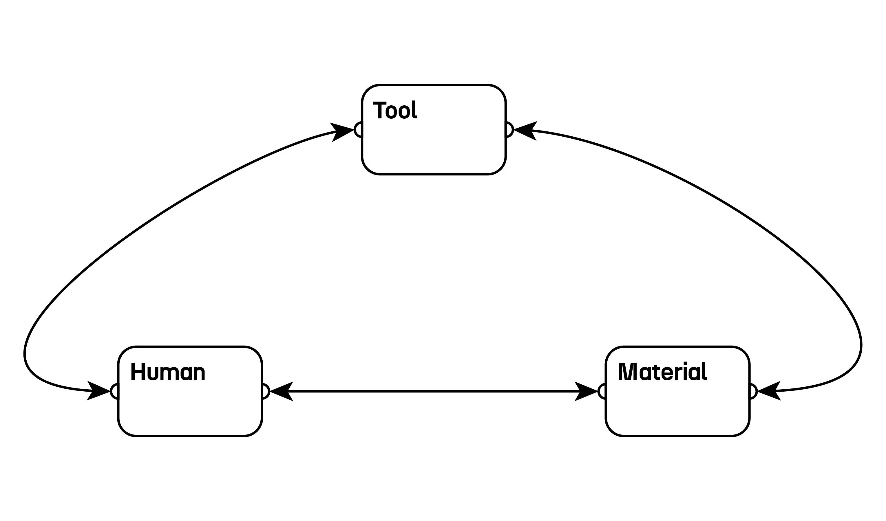

Unified Agency diagram. Source: Author

## Distributed Agency: Industrial and Digital Fragmentation

The industrial transformation traced through Taylorism and later digital workflows created what this research identifies as distributed agency: a configuration where creative control becomes fragmented across separate operational domains, each governed by different systems and often different human operators. This represents a different organizational form from unified agency, not merely a technological updating of traditional craft practice.

Distributed agency operates through the "externalization of knowledge, expectation, understanding, and other elements of self" across spatial and technological domains. In digital fabrication, this externalization becomes problematic fragmentation: the craftsperson’s unified practice gets distributed across discrete technological phases, each operating according to its own technical logic. Unlike the concept of "emplaced action," where place and action remain integrated, digital workflows create a "displaced action," where creative decisions become separated from their material consequences through layers of technological mediation.

Each stage of this distributed system operates as a different "place" with its own material and symbolic boundaries that shape what actions become possible. CAD environments privilege geometric precision and parametric relationships, effectively "placing" the designer within a mathematical abstraction that rewards certain types of thinking while constraining others. Toolpath generation software functions as an intermediary place governed by manufacturing efficiency and machine limitations, where the designer’s intentions must conform to algorithmic optimization routines. Finally, the physical fabrication environment operates according to mechanical precision and material properties, but by this point the maker has been effectively displaced from direct engagement with these material realities. This sequential displacement across technological places creates a crisis of accountability: when creative decisions become distributed across multiple technological domains, the maker loses the direct responsiveness that is central to emplaced action.

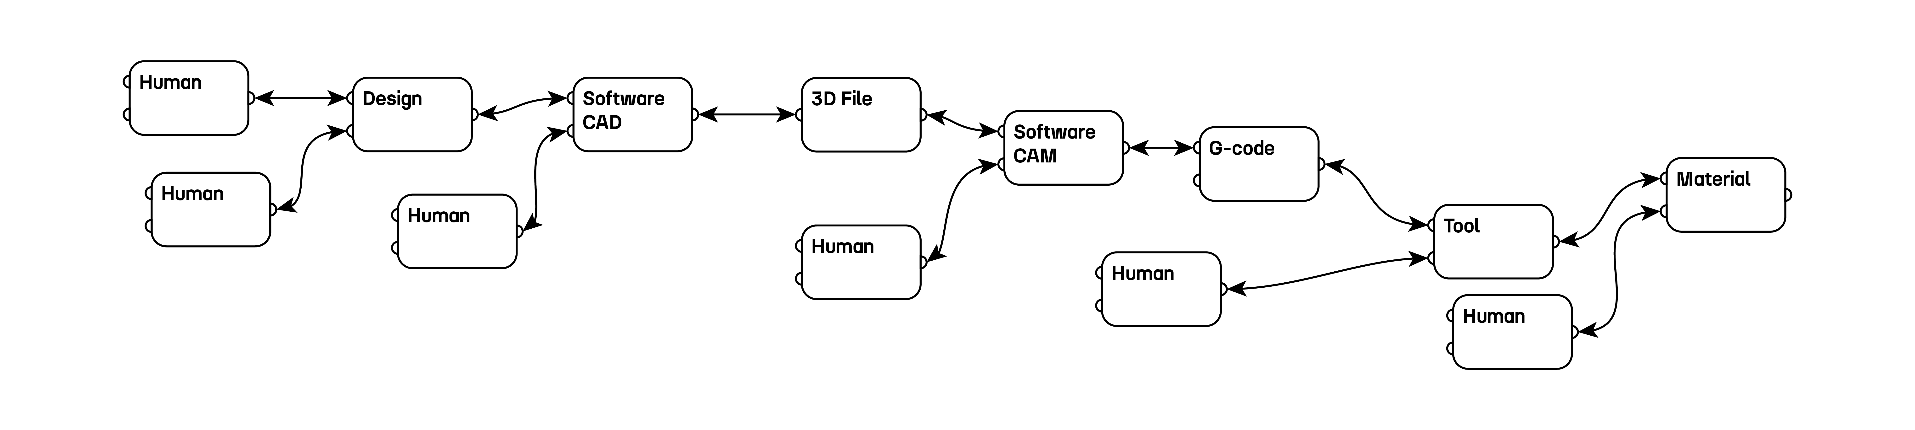

Distributed Agency diagram

## The Loss of Adaptive Authority

The biggest difference between unified and distributed agency lies not only in the number of technological intermediaries involved, but in the elimination of what this research identifies as adaptive authority, being the capacity for real-time modification of creative decisions based on emergent conditions. Traditional craft practice embedded this adaptive capacity throughout the making process, enabling continuous negotiation between intention and material response. Distributed agency, by contrast, concentrates adaptive authority within the initial design phase while rendering subsequent stages increasingly deterministic. Once geometric specifications are locked into CAD files and translated through manufacturing software, the system resists the kinds of responsive modifications that characterized traditional craft dialogue between maker and material.

The emergence of increasingly sophisticated computational processes, from parametric optimization to AI-generated design variations, intensifies this structural limitation. These developments may increase the sophistication of initial design exploration, but they operate within the same distributed architecture that concentrates creative authority in separate planning phases while rendering material execution increasingly automated and non-responsive.

# Towards Alternative Configurations

Understanding agency as organizationally configured rather than technologically determined suggests possibilities for alternative approaches to digital fabrication. Rather than accepting the distributed model as inevitable, this research explores whether digital systems might be structured to preserve adaptive authority throughout the making process, enabling the continuous dialogue between intention and material while leveraging the capabilities of contemporary fabrication technologies.

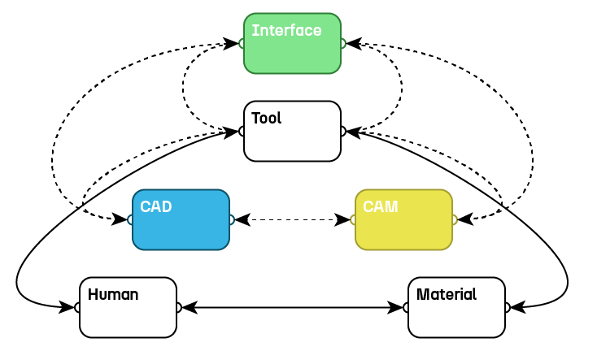

Toward Integrated Digital Agency diagram. Source: Author

# Reclaiming Agency Within Technological Constraints

Out of this historical trajectory from unified craft practice through industrial fragmentation to contemporary digital workflows emerges a clear challenge: the problem facing makers today is not technological limitation but organizational structure. The tools themselves, CNC machines, 3D printers, and parametric design software, represent unprecedented capabilities for material manipulation and geometric exploration. Yet their integration within distributed agency frameworks eliminates the adaptive authority that enabled traditional craftspeople to maintain creative control throughout the making process.

Current approaches to fabrication "democratization" have focused primarily on access, making industrial machines smaller, cheaper, and more widely available, without addressing the key workflow architectures that perpetuate the separation of conception from execution. The path forward followed by this research will require a tactical appropriation: working within existing technological ecosystems while reorganizing their logic to restore the continuous dialogue between intention and material response.

Unlike the Luddites’ strategic machine-breaking or the Arts & Crafts movement’s wholesale rejection of industrial methods, this approach recognizes that contemporary technological capabilities need not inevitably fragment creative agency. The challenge lies not in the machines themselves but in reorganizing how they are deployed within making workflows. The following chapters will examine how such reorganization might operate in practice, exploring pathways toward post-industrial craft practices that combine computational precision with organizational structures preserving the maker’s capacity for real-time adaptation, contextual response, and embodied decision-making.

**Chapter 2: Rethinking Democratization: Beyond Access to Preservation**

The historical trajectory examined in Chapter 1 has showed how creative agency has been systematically redistributed from unified practice to contemporary digital workflows. This analysis raises the question: if digital fabrication technologies possess unprecedented capabilities for material manipulation and geometric exploration, why do they continue to perpetuate the same distributed agency frameworks that eliminated adaptive authority? The answer lies in how the "democratization" itself has been conceptualized within digital fabrication discourse.

Rather than addressing the organizational structures that fragment creative agency, contemporary digital fabrication has pursued democratization primarily through expanded access to scaled-down industrial tools. This chapter will examine how this access-centered approach, while achieving remarkable quantitative success, fails to address the deeper structural issues identified in the historical analysis. By tracing the evolution from access-based democratization toward preservation-centered approaches, this chapter will try to pursue a reconceptualization of what democratic making might mean in digital contexts.

# The Access Paradigm and Its Achievements

This access-centered understanding of democratization has become the dominant paradigm within contemporary digital fabrication discourse. Neil Gershenfeld’s[10] foundational vision for FabLabs[11] promised "personal fabrication" enabling "almost anyone to make almost anything" (Gershenfeld 2007), positioning digital fabrication as the natural evolution of personal computing—bringing the same accessibility that desktop computers brought to information processing into the realm of physical manufacturing. This vision emphasized scaling down industrial production capabilities to individual users, making sophisticated fabrication tools available in community workshops and educational institutions.

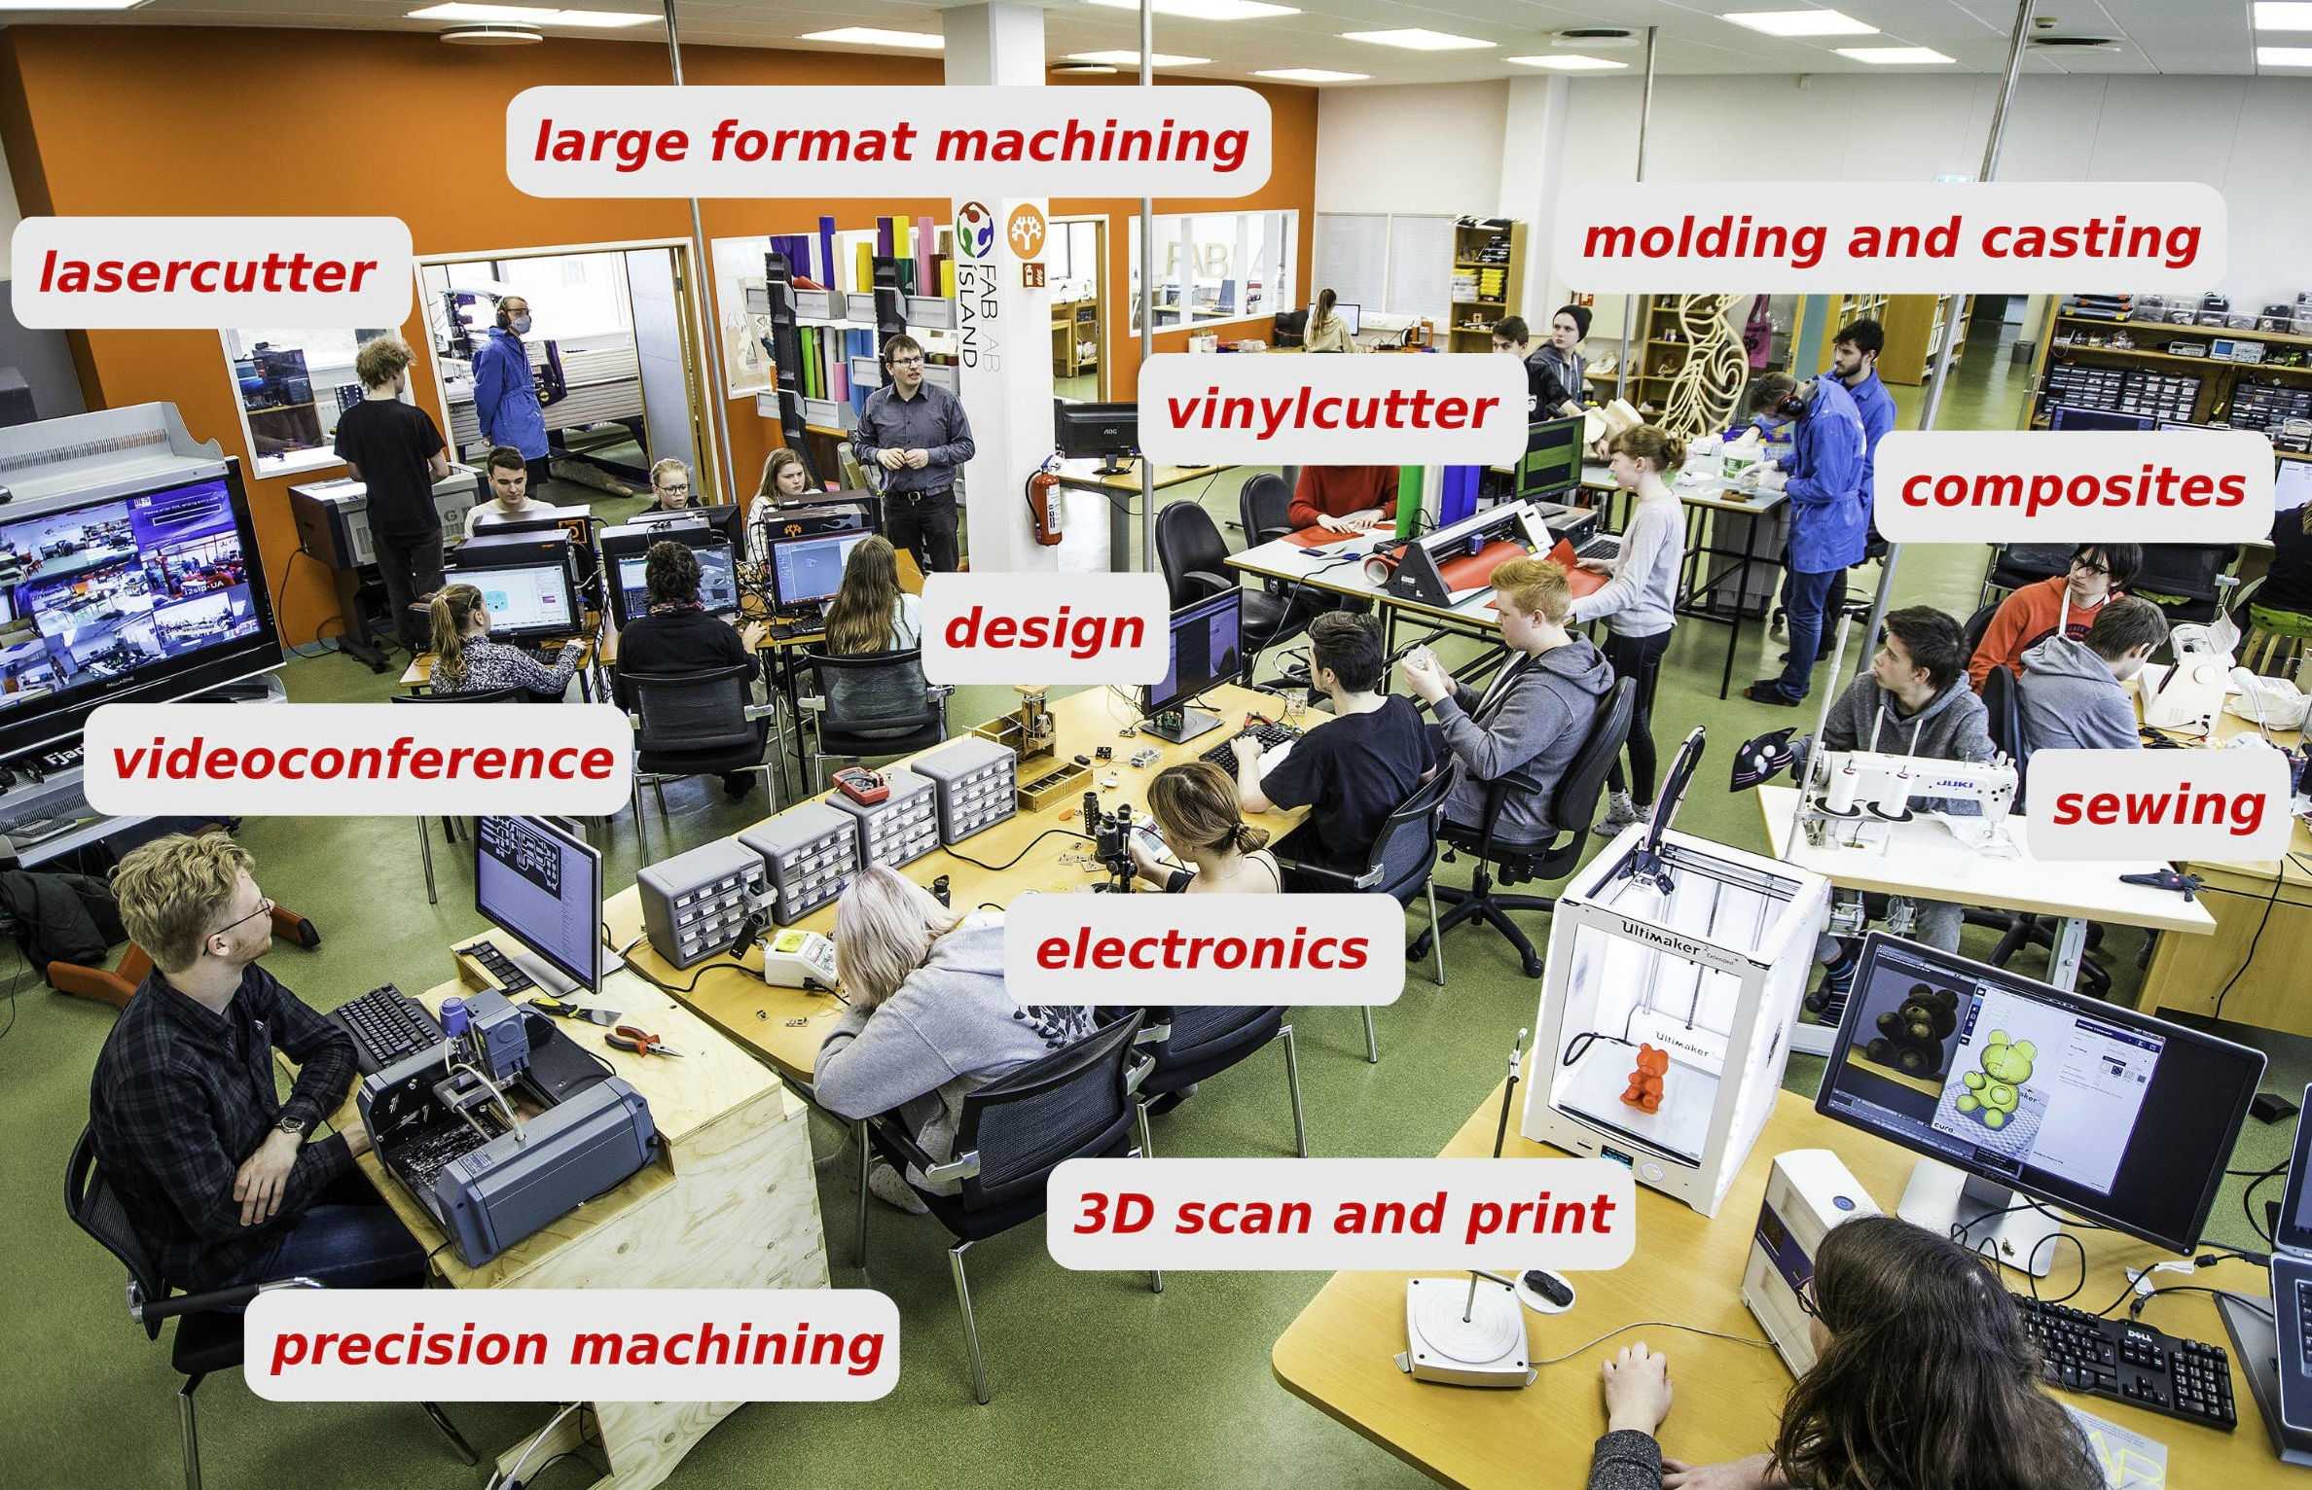

Tools in a Fab Lab. Source: Fab Foundation, 2024

Building on this foundation, the broader maker movement, as articulated by Mark Hatch, advocated for "radically democratizing access to the tools of innovation" (Hatch 2013), framing making as both a form of personal empowerment and economic opportunity. Hatch’s manifesto positioned the maker movement as a response to mass production’s alienation, promising that widespread access to fabrication tools would restore individual agency in production while fostering innovation and entrepreneurship at the grassroots level.

This approach has achieved remarkable quantitative success: from fewer than 50 FabLabs worldwide in 2009 to over 2,000 by 2023 (Fab Foundation 2024), there’s been an unprecedented expansion of access to sophisticated production capabilities.

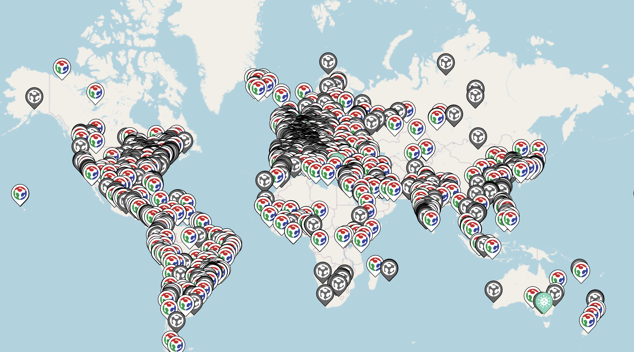

Global distribution of FabLabs. Map showing the locations of FabLabs around the world. Source: Fab Foundation, 2024

This democratization of digital fabrication extends beyond physical tools to software infrastructures. Open-source[12] and free CAD alternatives like FreeCAD[13], Blender[14] or TinkerCAD[15] combined with educational programs to know how to use the tools, have reduced barriers to digital design literacy. Contemporary maker spaces enable individual access to CNC machines[16], 3D printers[17], and laser cutters[18] for modest fees (sometimes even for free), genuinely transforming the economic conditions of making.

Yet this access-focused paradigm highlights certain limitations when examined against historical precedents of successful democratization movements. The expansion of who can use fabrication tools does not address how those tools structure agency within making processes. As Tanenbaum et al. observe, maker practices still depend heavily on existing industrial infrastructure and face challenges "when it comes to scaling up production and distribution" (Tanenbaum et al. 2013).

# The Preservation Problem: What Access Cannot Address

While the quantitative expansion of fabrication access represents genuine progress, it reveals limitations in how democratization has been conceptualized. What contemporary digital fabrication lacks is what this research identifies as a preservation problem: the loss of tacit knowledge and embodied practices that characterize skilled making. This goes beyond the historical fragmentation patterns analyzed in Chapter 1 to encompass how knowledge itself is transmitted, maintained, and evolved within making communities.

Richard Sennett’s analysis of craftsmanship emphasizes that "the desire to do something well for its own sake" (Sennet 2009) requires forms of embodied learning that resist systematic codification. Unlike explicit knowledge that can be documented in manuals or encoded in software, tacit knowledge emerges through sustained engagement with materials, tools, and techniques.

Contemporary digital fabrication workflows eliminate opportunities for this knowledge transmission. While FabLabs and maker spaces provide access to sophisticated tools, they typically operate through standardized tutorials and predetermined project sequences that prioritize rapid skill acquisition over deep material understanding. The emphasis on "democratizing" access often translates into simplifying workflows to reduce learning curves, eliminating the complex, time-intensive processes through which tacit knowledge traditionally develops.

This preservation problem manifests through persistent organizational structures that extend beyond individual tool use. Despite the collaborative and educational dimensions of maker spaces, the workflow architecture maintains the distributed agency pattern traced in Chapter 1. Creative decisions remain concentrated in separate design phases, while material execution follows predetermined procedures that eliminate opportunities for the responsive adaptation. The result is a democratization that provides access to tools without preserving the knowledge systems that enable those tools to support genuine creative agency.

The insight that emerges from this analysis is that democratization cannot be achieved through access alone, it requires organizational innovation that preserves the continuity of creative decision-making throughout the making process. This shifts focus from who can use fabrication tools to how those tools can be structured to maintain what was identified in Chapter 1 as unified agency.

# Redefining Democratization: Process Over Access

Through the analysis of the preservation problem it’s possible to raise the question about how "democratization" has been conceptualized within digital fabrication discourse. While the term implies expanding democratic participation, current approaches, as mentioned, focus primarily on access expansion rather than examining what democratic participation actually requires. Before proposing alternative models for fabrication democratization, it becomes necessary to question what "democracy" itself demands and how those requirements might apply to making contexts.

The analysis of different precedents and patterns suggest that democratization movements across multiple domains initially focus on access expansion before recognizing deeper structural challenges. Political democratization, educational reform, and cultural preservation movements all showcase patterns that would align with it: early phases emphasize expanding participation within existing systems, while later phases require fundamental transformation of the systems themselves. For instance, political democratization initially focused on expanding voting rights, but later required systematic changes like proportional representation systems such as the D’Hondt method[19] to ensure genuine democratic representation rather than mere voting access. Similarly, educational democratization moved beyond simply expanding school enrollment to developing pedagogical approaches that understand and accommodate diversity in the classroom, adapting curricula to different learning styles and cultural backgrounds rather than imposing standardized approaches. These precedents suggest that fabrication democratization may be encountering similar limitations inherent to access-based approaches.

Rather than assuming that broader tool access automatically produces democratic participation, the following analysis will examine what democracy actually requires and how those requirements might inform alternative approaches to fabrication democratization. By analyzing democratic theory alongside cross-cultural preservation practices, this chapter will attempt to develop frameworks for distinguishing between superficial access and substantive democratic participation in production processes.

## Deconstructing "Democratization": What Democracy Actually Requires

The theoretical framework established requires a deeper examination of the term "democratization" itself and its specific application to fabrication contexts. While democratic theory provides extensive analysis of political participation, its principles have been applied to fabrication with insufficient critical examination of what democratic participation might actually require within making processes. The word "democracy" derives from the Greek δημοκρατία (demokratia) demos (people) + kratos (power/rule), meaning rule by the people. This etymology suggests that democratization involves the distribution of ruling authority rather than expanded access to predetermined systems, a distinction with big implications for how fabrication democratization should be conceptualized.

Political democracy, at its core, requires the distribution of decision-making authority among participants rather than merely access to predetermined decision-making processes. As Robert Dahl’s[20] foundational analysis demonstrates, democratic systems must provide "effective participation" (Coglianese 1990) where citizens have "basic political rights and liberties, such as free expression, and allows persons to live under laws of their own choosing" (Coglianese 1990), and enlightened understanding enabling informed choice among alternatives. Crucially, democracy requires what Dahl terms "final control over the agenda" (Mayhew 2017), the authority to determine not just outcomes within predetermined options, but the capacity to define what questions get asked and how they are framed. Distinguishing genuine democratic participation from consultative processes that solicit input within predetermined parameters while concentrating agenda-setting authority elsewhere.

Applied to fabrication contexts, this analysis reveals that current maker spaces, despite their collaborative ethos, preserve a fabrication autocracy, a system that concentrates creative authority in separate design phases while relegating material execution to predetermined procedures that eliminate participant agency. Genuine fabrication democratization would require the distribution of creative decision-making authority throughout making processes, enabling makers to exercise "final control over the agenda" not just in initial design specification, but in determining how fabrication workflows themselves operate and evolve in response to material conditions and emergent discoveries.

## The Representation Problem in Fabrication Democracy

Having established that genuine democratization requires the distribution of decision-making authority rather than mere access expansion, it becomes necessary to examine how such authority might be structured within fabrication contexts. Political democracy usually confronts the challenge of representation: how to enable large-scale collective decision-making while preserving individual agency? This requires sophisticated institutional frameworks, electoral systems, deliberative processes, and constitutional protections that mediate between individual preferences and collective outcomes without eliminating personal autonomy.

Fabrication democratization faces analogous representational challenges: how to enable collective access to sophisticated manufacturing capabilities while preserving individual makers’ authority to determine their own creative processes? Yet current digital fabrication has developed no equivalent to democratic political institutions. Instead, it has adopted a technocratic representation, expert-designed software interfaces and standardized file formats that mediate between human intention and material execution while eliminating opportunities for maker input beyond initial design specification.

This technocratic approach mirrors Joseph Schumpeter’s[21] theory of democracy as "competitive leadership" (Schumpeter 1950), a system that preserves formal democratic procedures while concentrating substantive decision-making authority within expert institutions. Just as this limited democracy enables citizen participation within predetermined choices while eliminating popular control over the agenda setting, just as current fabrication democratization enables maker participation within predetermined expert designed workflow structures while eliminating authority over how those structures have to be operated.

## Participatory Democracy and Making

The technocratic representation reflects what participatory democratic theorists have long criticized in conventional political systems. Rather than accepting the limited model of democracy as competitive leadership, theorists like Carole Pateman advocate for democracy as active participation across all spheres of social life, "a society where all political systems have been democratised and socialisation through participation can take place in all areas" (Pateman 1976). Pateman argues that democratic capacity cannot be developed through formal instruction alone but emerges through the practice of exercising democratic authority in concrete contexts.

For fabrication democratization, out of this participatory approach can be extracted that creative agency develops itself through sustained engagement with decision-making throughout the making process rather than through standardized training in predetermined procedures. This would challenge the separation between tool designers and tool users that characterizes current maker spaces, and processes, requiring structures that enable makers to collectively determine how fabrication workflows themselves operate and evolve. Instead of accepting expert-designed workflow structures as fixed constraints, participatory fabrication would enable makers to exercise that "final control over the agenda".

# Deconstructing "Preservation": Beyond Cultural Heritage Models

Out of the democracy framework outlined in this research can be assumed that genuine fabrication democratization requires preserving makers’ capacity for ongoing creative authority rather than simply expanding access to predetermined tools. This shifts the focus from "democratization" as access provision to "democratization" as preservation of agency. But what kind of preservation enables rather than constrains democratic participation? The concept of "preservation" itself requires an examination, as its application to craft knowledge has been heavily influenced by cultural heritage frameworks that reproduce the same static approaches that align with access-based democratization.

Understanding preservation through cross-cultural perspectives can reveal assumptions embedded within Western conservation models and might highlight alternative approaches more suitable for maintaining the creative agency that democratic fabrication requires.

## Preservation as Dynamic Process vs. Static Conservation

Traditional cultural preservation models, developed primarily for archaeological, crafts, and architectural contexts, emphasize conservation of existing artifacts and documentation of historical practices. This approach, rooted in western "museum culture", treats cultural objects as fixed entities requiring protection from change rather than as elements within ongoing living traditions that respond to new conditions and challenges.

The 2003 UNESCO Convention for the Safeguarding of Intangible Cultural Heritage marked a shift in this perspective by recognizing that cultural heritage extends beyond tangible things to include "identification, documentation, research, preservation, protection, promotion, enhancement, transmission" (UNESCO 2003). More importantly, the convention defines intangible cultural heritage as something that is "constantly recreated by communities and groups in response to their environment" (UNESCO 2003), explicitly acknowledging its living, evolving nature.

However, this framework still emphasizes documenting and officially recognizing traditional practices rather than preserving communities’ ability to adapt and change those practices. The UNESCO approach, while acknowledging living practices, still requires processes that tend to crystallize traditions into documentable forms rather than preserving their adaptive capacity, the quality that democratic fabrication systems must maintain to enable ongoing maker authority over creative processes.

## Cross-Cultural Models of Adaptive Preservation

The static documentation approaches critiqued highly contrast with preservation practices across different cultural contexts that prioritize maintaining agency and adaptive capacity over material authenticity. These alternative models demonstrate how preservation can support the kind of ongoing democratic authority that participatory fabrication requires.

### Cuban Automobile Preservation: Functionality Through Adaptation

Cuba’s preservation of classic American automobiles exemplifies a functional preservation, the maintainance of cultural significance through continuous adaptation oposed to static conservation. Following the 1959 Cuban Revolution and subsequent U.S. embargo, Cubans maintained an estimated 60,000 classic American cars through creative adaptation. As the Diplomatic Times (2019) reports, "About half of the cars originate from the 1950s, while 25 percent are from the 1940s and another 25 percent are from the 1930s. A lot of them have been passed down from generation to generation, along with the mechanical genius."

These vehicles remain culturally significant not despite their modifications but because of them. Their external appearancespreserve historical recognition value while their internal systems have evolved into hybrid assemblages. "A common substitution on the old 1950s era cars on the island are diesel engines for the old straight-six or V-8 engines originally in the cars, due to diesel’s lower cost on the island, and the better fuel efficiency of the engines," (Diplomatic Times 2019) with "diesel engines from Russian trucks or boats" (Diplomatic Times 2019) replacing original components.

This preservation approach prioritizesthe ongoing functionality and cultural continuity over "strict" tangible authenticity. The cars remain integrated within contemporary Cuban life, functioning as taxis and tourist attractions rather than museum pieces, showcasing preservation through active use rather than protection from use. As Adewale (2024) observes, "While some people might expect these old cars to be museum pieces, they’re part of everyday life in Cuba."

### Māori River Preservation: Relational Continuity Through Legal Innovation

New Zealand’s legal recognition of the Whanganui River as a living entity with "the same rights and responsibilities as a person" (Pāremata Aotearoa 2017) exemplifies preservation through transformed conceptual frameworks rather than material conservation. This approach emerged from Māori understanding expressed in the saying "Ko au te awa, ko te awa ko au" (I am the river, and the river is me), where the river name "Awa Tupua" includes "the whole river system, its spirit, and the people that are related to it" (National Library of New Zealand 2017).

Rather than treating the river as a natural resource requiring protection through regulatory restriction, this model empowers the Māori to manage and protect the river based on their traditional ecological knowledge. As VijayKuma (2019) notes, "As a consequence of this recognition, the Maori are now empowered to manage and protect the river based on their traditional ecological knowledge." Preservation here operates through maintaining relationships and ongoing interactions rather than controlling physical attributes or preventing change.

This relational approach recognizes that preservation must account for living connections between people, practices, and environments rather than treating cultural elements as discrete objects requiring isolation from contemporary influences.

### Implications for Digital Fabrication Democratization

These diverse preservation models highlight shared principles that might address the democratization challenges identified earlier. Both Cuban functional adaptation and Māori relational continuity prioritize process over product, relationships over artifacts, and adaptation over stasis. As Muñoz Zanón (2025) concludes from this analysis, effective preservation approaches should "capture process knowledge and decision-making rather than just final geometries, preserve the dynamic relationship between maker, material, and tool, and allow for adaptation and evolution rather than freezing techniques in time."

Taking a look at the fabrication democratization aspect, out of these principles it can be asummed that preserving makers’ agency requires organizational structures that maintain what the Cuban model showcases: the capacity for ongoing functional adaptation in response to changing conditions. Similarly to the Māori approach, genuine fabrication democratization would preserve makers’ collective authority to determine how systems evolve, maintaining the relational continuity between human intention and material response.

# Documentation as Process Preservation

The preservation approaches demonstrated by Cuban mechanics and Māori river stewardship raise questions about how digital fabrication systems might maintain makers’ adaptive authority. These become particularly present when examining how fabrication knowledge is documented and transmitted. Current fabrication documentation perpetuates the technocratic representation characteristic of the distributed agency model, enabling participation within predetermined procedures while eliminating authority over how those procedures operate. Standard fabrication documentation (CAD files, parameter lists, step by step tutorials…) work as expert-designed interfaces that mediate between human intention and execution, eliminating opportunities for creative input beyond initial design specification.

However, examining documentation practices across different contexts reveal alternative approaches that align better with the dynamic preservation principles and participatory democratic theory already examined.

## Educational Documentation: Capturing Learning Processes

The FabAcademy[22] and Fabricademy[23] documentation sites provide examples of documentation that capture learning processes besides just technical outcomes. Unlike traditional technical manuals that present polished procedures, these educational platforms require students to document their entire learning journey, including failed experiments, debugging processes, and iterative refinements. Students document not only successful fabrication outcomes but also the problem-solving processes that led to those outcomes, creating records of adaptive authority.

Fabricademy specifically, becomes an interesting example as it extends this approach to textile and bio-material fabrication, where material unpredictability requires even greater adaptive capacity. Students document experiments with living materials and organic processes where following predetermined procedures often fails, and creative adaptation becomes essential. The resulting documentation captures the iterative process of material negotiation that can also be seen in traditional craft knowledge.

## Workflows as Narrative Preservation

Tandem system (Tran O’Leary et al. 2024) represents another interesting approach to process-oriented documentation, implementing entire fabrication workflows as computational notebooks that preserve the complete narrative of creation. Rather than abstracting away the making process into separate CAD/CAM phases, Tandem maintains continuity between design decisions and material execution through "reproducible fabrication workflows" (Tran O’Leary et al. 2024).

Interestingly, the project acknowledges that reproduction is not repetition, each implementation involves contextual adaptations based on available materials, equipment variations, and maker expertise. By implementing workflows as modifiable programs rather than fixed procedures, the system enables a generative reproduction, allowing to maintain creative agency while building on previous work, representing a significant switch from standard CAD/CAM workflows that concentrate creative decisions in separate design phases.

# The Limits of Algorithmic Preservation

While these educational documentation approaches highlight promising alternatives to static preservation, they still operate within digital systems that fundamentally assume craft knowledge can be captured and transmitted through explicit documentation. This assumption has led contemporary approaches toward an even more technologically intensive solution: artificial intelligence and machine learning as comprehensive approaches to preserving and transmitting embodied knowledge. Suggesting that if human documentation proves inadequate, computational systems might decode the embodied knowledge through pattern recognition and data analysis.

However, machine learning approaches to kowledge preservation create a paradox: the more precisely algorithms attempt to measure and classify skilled practice, the more they help discover dimensions of that practice that resist an algorithmic categorization. This suggests that the problem with embodied knowledge preservation may not be inadequate computational architectures, but rather the conceptual framework that treats embodied knowledge as extractable data rather than contextual relationships between makers, materials, and tools.

## Testing the Limits of preservation. AI.RTISANSHIP

Even with the aforementioned problems with algorithmic approaches to craft preservation, these "limitations" demanded empirical investigation. If computational systems truly cannot capture the adaptive authority that democratic making requires, this assumption needed testing through direct experimentation. To investigate these limitations empirically, this research developed as a first intervention the AI.RTISANSHIP experiment, an attempt to capture and digitize traditional pottery techniques through computer vision and machine learning systems, designed not to succeed but to reveal precisely where and why such approaches fail.

The goal was to create a machine learning model capable of analyzing artisanal hand movements and providing real-time feedback on the correctness of performed actions, essentially functioning as a "digital master" for craft learning. By pushing algorithmic preservation to its technical limits, the experiment aimed to identify the specific dimensions of craft knowledge that resist computational capture, thereby informing alternative future approaches.

## Technical Developement: Digitizing Embodied Knowledge

The AI.RTISANSHIP system made use of MediaPipe’s holistic model to track 33 pose landmarks, 21 landmarks per hand, and facial features, generating 225-dimensional vectors for each frame of movement. The machine learning pipeline processed sequences of 30 frames (approximately one second of movement) through a three layer bidirectional LSTM network with dropout regularization and L2 penalty terms to prevent overfitting.

Data collection involved recording multiple pottery throwing sessions, manually labeling frame collections of movements as "correct" or "incorrect," and training the neural network to recognize these patterns in unseen views. The system achieved accuracy in distinguishing between predefined movement categories, successfully identifying differences between throwing techniques and providing real-time classification through a web interface.

However, this technical "success" started highlighting conceptual issues mentioned before that only became apparent through the extended testing with the potters.

## The "Unmeasurable" Dimensions of Knowledge

The experiment’s concluded that craft knowledge works through dimensions that resist algorithmic capture. Computer vision could detect hand positions with great precision but remained blind to the tactile feedback that made those positions, the subtle resistance of clay indicating proper centering, texture changes indicating moisture, or vibrations warning of collapsation. These sensory channels, essential for pottery practice, exist entirely outside the visual domain that computer vision systems can access.

Beyond these sensory limitations, the experiment exposed deeper problems with the assumption that skilled practice follows standardizable patterns. Each participating artisan showcasded different approaches to identical pottery tasks, reflecting not just technical variations but personal relationships with clay developed through years of individual practice. Where one potter might relied on strong decisive movements, another employed gentle, patient techniques. These differences stemmed not from varying levels of skill but from unique personal histories, physical capabilities, and aesthetic preferences that had developed into distinct making "philosophies".

In it’s core, the machine learning system’s requirement for binary classification ("correct" versus "incorrect") proved conceptually inappropriate for pottery practice. The participating potters emphasized that successful throwing depends on continuous adaptation to emergent material conditions rather than adherence to predetermined techniques. This adaptive capacity, cannot be reduced to pattern recognition algorithms that require standardized input categories. Where pottery expertise emerges from continuous dialogue between maker and material, the AI system imposed predetermined classifications that eliminated precisely the adaptive responsiveness that characterizes skilled practice.

## Implications for Digital Fabrication Preservation

The real-time feedback mechanism (color-coded overlays indicating "correct" or "incorrect" movements) created additional problems that highlighted even further the inadequacy of the approach. The potters, despite acknowledging the potential of the tool for educational purposes, reported that the visual feedback disrupted their attention to tactile cues. The system’s focus on visual movement patterns diverted attention from the sensory channels through which pottery expertise actually operates.

The attempt to extract explicit rules from embodied practices assumes that skilled knowledge can be decomposed into discrete, transferable components. Yet the experiment, as was guessed before starting it, demonstrated that pottery expertise exists not in specific movements but in the capacity for contextual adaptation, precisely what the machine learning system eliminated through its standardized classifications.

Out of these findings, it is possible to suggest that effective craft preservation cannot operate through documentation technologies that abstract away material context and environmental variation.

Effective preservation, would need to maintain the conditions for adaptive response rather than understanding standardized procedures. Representing a shift from traditional documentation based approaches towards a preservation method that maintain the organizational structures only, enabeling ongoing creative adaptation.

## Beyond Documentation: Toward Ecological Preservation

Experiment’s limitations do not suggest fully abandoning documentation altogether, but rather reconceptualizing what documentation means within embodied knowledge preservation contexts. Documentation remains essential, but it must acknowledge that each implementation of documented knowledge will necessarily differ based on contextual variables, material conditions, and individual maker characteristics.

Rather than attempting to capture universal techniques through computational standardization, effective preservation requires documentation frameworks that explicitly account for contextual variation. This involves creating technological environments that preserve not just movement patterns but the decision-making processes that inform adaptive responses to changing conditions. Such systems would document the reasoning behind technical choices, the environmental factors that influence material behavior, and the range of acceptable variations rather than singular "correct" procedures.

This contextual approach to documentation would treat preservation as the maintenance of conditions for ongoing creative adaptation. Digital fabrication systems (or workflows) designed according to these principles would preserve material feedback channels, enabling real-time modification based on emergent conditions, and maintain maker authority. Documentation would function as a scaffold for contextual learning rather than a template for mechanical reproduction.

The following chapters will explore how such contextually-aware preservation might operate within digital fabrication workflows, building on the AI.RTISANSHIP experiment’s insights to develop newer approaches for preservation, reflecting the unique intersection of maker, material, and circumstance.

**Chapter 3: From Theory to Practice - Experimental Pathways**

The theoretical framework developed in the previous chapters suggested that genuine democratization of digital fabrication requires preservation-based approaches that maintain adaptive authority rather than simply expanding access to predetermined tools. Yet this analysis raised questions about implementation: *How might such preservation actually operate within existing technological contexts?* *Could alternative "interfaces" bridge the gap between computational precision and embodied expression?* The following interventions sought to address these questions through practical experiments that tested the theoretical propositions in real-world making contexts.

This chapter will document different "interventions" that progressively refined approaches to preserving the embodied knowledge within digital workflows. Each experiment built upon insights from the previous, leading to the development of Ars Post Faber, the open-source Grasshopper[24] plugin[25] that embodies the research’s theoretical conclusions.

# *CR3ATED*: Reimagining CAD Interfaces for Artisan Expression

*"If craftsmanship’s essence lies in the creative problem solving process, how can digital fabrication tools become active participants in it rather than automation devices?"*

## Exploring Alternative Interface Approaches

Building upon insights from AI.RTISANSHIP, it was concluded that computational systems could successfully capture and analyze certain patterns of skilled movement, yet this technical capability highlighted a bigger challenge where the preserved data represented only "surface" manifestations of embodied knowledge rather than the adaptive reasoning processes. This raised a different question: *Rather than attempting to extract embodied knowledge from practitioners, what if digital tools could be designed to better support and amplify the adaptive decision-making processes that characterize skilled practice?*

This inquiry led to the development of *CR3ATED*, a web-based application designed to test alternative interface approaches within digital design and fabrication workflows. Where AI.RTISANSHIP looked to decode existing craft knowledge through computational analysis, *CR3ATED* explored how interface design itself might preserve creative expression by exploring different human-software interactions.

The *CR3ATED* experiment investigated whether alternative modes of human-software interaction could maintain the continuity between creative intention and material execution that conventional CAD workflows tend to fragment. The central hypothesis was that interface design actively constructs the kinds of creative relationships that become possible within digital fabrication workflows, suggesting that preserving craft agency might require different approaches to how makers engage with computational design tools.

## Craftinnova: Testing Alternative Interfaces

The CR3ATED web application was developed specifically for the "Nuevos Métodos de Aprendizaje Artesano" workshop at CRAFTINNOVA[26], creating an opportunity to test these alternative interface approaches with practicing artisans in a real-world context. The workshop brought together traditional craftspeople with clay 3D printing technology, creating an ideal laboratory for investigating how interface design affects the preservation of creative expression.

Rather than using conventional CAD software, the webapp, implemented a touch-based sketching interface that allowed participants to create 3D models through direct manipulation on mobile devices. The application translated 2D sketches into revolution surfaces suitable for clay printing, maintaining the intuitive hand-to-head connection that characterizes crafts while engaging with the digital fabrication capabilities of the machine.

This approach acknowledged that conventional CAD systems fail to express the imperfection and responsiveness from the craft practice. By creating a workflow that began with tactile sketching and culminated with material engagement, the experiment explored how technology might contribute to craft preservation by becoming integrated into evolving creative practice rather than replacing traditional methods.

## Material Continuity and Digital Mediation

An important aspect of the workflow developed involved preserving material continuity between digital design and physical fabrication. The clay printer, despite its digital control system, interacts with clay according to the same physical principles that govern hand techniques, unlike the normally used polymers in additive manufacturing that cannot be hand-treated. Clay maintains its material properties regardless of whether it is shaped by hand or extruded through a mechanical nozzle, maintaining material coherence across the digital/physical boundary.

This materiality creates productive constraints rather than arbitrary limitations. Workshop participants encountered the clay printer’s capabilities and limitations as a new set of material conditions to navigate, drawing on their traditional knowledge while developing new skills specific to the printer. Unlike conventional CAD/CAM workflows that abstract away material properties through geometric representation, the *CR3ATED* approach maintained material feedback throughout the process.

The touch interface proved to be important for preserving this material relationship. Whereas CAD requires learning abstract geometric manipulation techniques, sketching with the finger or a stylus maintains the tactile connection between hand movement and form development. Participants of the workshop were able to leverage their existing skills while engaging with digital fabrication, rather than having to master entirely new representational systems.

## Expanding vs. Replacing Practice

The workshop generated diverse responses from the participants, showing different ways that digital tools might relate to traditional practice. For most, the clay printing process represented a new exploration rather than a shift in their approach. These artisans engaged with the technology as they might with any new tool or technique, integrating it within their existing practice.

However, other participants experienced the workshop as an expansion of their literacy in both digital and material domains. For these makers, the interface exploration enabled forms of creative expression and production that would have been difficult (or impossible) to achieve through either traditional hand-building or conventional CAD approaches.

**Chapter 4: Ars Post Faber: Towards Unified Digital Agency**

**Chapter 5: Conclusion. Questioning the Future of Human-Machine Interaction**

**Bibliography**

**Appendices**

# AI.RTISANSHIP Technical Documentation

# Workshop Materials and Protocols

# Software Implementation Details

# Extended Bibliography

Adewale, P. 2024. “Why Does Cuba Have so Many Old Cars?” *Classic Decoder*. <https://classicdecoder.com/why-does-cuba-have-so-many-old-cars>.

Byron, G. G. 1816. “Song for the Luddites.” *Union Songs*. <https://unionsong.com/u771.html>.

Coglianese, C. 1990. “Review of Democracy and Its Critics by Robert a. Dahl.” *Michigan Law Review* 88 (6): 1662–67. [\url{https://scholarship.law.upenn.edu/cgi/viewcontent.cgi?article=2245&context=faculty_scholarship}](\url%7bhttps://scholarship.law.upenn.edu/cgi/viewcontent.cgi?article=2245&context=faculty_scholarship%7d).

Crane, W. 1892. *The Claims of Decorative Art*. London: Lawrence; Bullen. <https://archive.org/details/claimsofdecorati00cran>.

Diplomatic Times. 2019. “How Do Cuba’s Vintage American Cars Still Run Like New?” *Diplomatic Times*. <https://diplomatictimes.net/2019/01/01/how-do-cubas-vintage-american-cars-still-run-like-new/>.

Fab Foundation. 2024. “Fab Foundation.” <https://fabfoundation.org/>.

Gershenfeld, N. 2007. *Fab: The Coming Revolution on Your Desktop-from Personal Computers to Personal Fabrication*. New York: Basic Books.

Hatch, M. 2013. *The Maker Movement Manifesto: Rules for Innovation in the New World of Crafters, Hackers, and Tinkerers*. New York: McGraw-Hill Education.

Mayhew, D. 2017. “Robert a. Dahl: 17 December 1915 - 5 February 2014.” *Proceedings of the American Philosophical Society* 161 (4): 344–47. <https://www.amphilsoc.org/sites/default/files/2018-03/attachments/Dahl.pdf>.

Morris, W. 1882. “The Lesser Arts of Life.” In *Lectures on Art Delivered in Support for the Society for the Protection of Ancient Buildings*, 174–232. London: Macmillan; Co.

Muñoz Zanón, J. 2025. “Embodied Knowledge in Digital Spaces: Towards Human-Centered Fabrication Formats.” In *Fab25 Czechia – Bridge the Gap (Fab25)*. Zenodo. <https://doi.org/10.5281/zenodo.16211937>.

National Library of New Zealand. 2017. “Change-Maker — the Whanganui River.” <https://natlib.govt.nz/he-tohu/learning/social-inquiry-resources/cultural-interaction/cultural-interaction-supporting-activities-and-resources/change-maker-whanganui-river>.

Niedderer, K. 2024. “Embodied Craft Practices.” In *Routledge eBooks*. <https://doi.org/10.4324/9781003328018-8>.

Pāremata Aotearoa. 2017. “Innovative Bill Protects Whanganui River with Legal Personhood.” *New Zealand Parliament*. <https://www.parliament.nz/en/get-involved/features/innovative-bill-protects-whanganui-river-with-legal-personhood/>.

Pateman, C. 1976. *Participation and Democratic Theory*. Structural Analysis in the Social Sciences. Cambridge: Cambridge University Press.

Richardson, G. 2008. “Medieval Guilds.” Edited by R. Whaples. <https://eh.net/encyclopedia/medieval-guilds/>.

Ruskin, J. 1892. *The Nature of Gothic: A Chapter of the Stones of Venice*. Hammersmith: Kelmscott Press. <https://archive.org/details/natureofgothicch00rusk/page/n9/mode/2up>.

Schumpeter, J. A. 1950. *Capitalism, Socialism, and Democracy*. 3rd ed. <https://archive.org/details/j.-schumpeter-capitalism-socialism-and-democracy>.

Sennet, R. 2009. *The Craftsman*. London: Penguin Random House.

Tanenbaum, J. G., A. M. Williams, A. Desjardins, and K. Tanenbaum. 2013. “Democratizing Technology: Pleasure, Utility and Expressiveness in DIY and Maker Practice.” In *Proceedings of CHI 2013: Changing Perspectives*, 2603–12. Paris: ACM. <https://doi.org/10.1145/2470654.2481360>.

Taylor, F. W. 1911. *The Principles of Scientific Management*. New York: Harper & Brothers. <https://archive.org/details/principlesofscie00taylrich/page/n5/mode/2up>.

The Free Library. 2014. “William Morris - Art and Idealism.” *The Free Library*. <https://www.thefreelibrary.com/William+Morris+-+art+and+idealism.-a018275725>.

Thomis, M. I. 1993. *The Luddites: Machine-Breaking in Regency England*. Modern Revivals in Economic and Social History. Aldershot: Gregg Revivals.

Tran O’Leary, Jasper, Thrisha Ramesh, Octi Zhang, and Nadya Peek. 2024. “Tandem: Reproducible Digital Fabrication Workflows as Multimodal Programs.” In *Proceedings of the 2024 CHI Conference on Human Factors in Computing Systems*, 1–15. CHI ’24. New York, NY, USA: Association for Computing Machinery. <https://doi.org/10.1145/3613904.3642751>.

UNESCO. 2003. “Text of the Convention for the Safeguarding of the Intangible Cultural Heritage.” <https://ich.unesco.org/en/convention>.

VijayKuma, R. 2019. “Integrating Indigenous Knowledge and Traditional Practices for Biodiversity Conservation in a Modern World.” *Environmental Reports*. <https://er.researchfloor.org/wp-content/uploads/2019/10/Integrating-Indigenous-Knowledge-and-Traditional-Practices-for-Biodiversity-Conservation-in-a-Modern-World.pdf>.

1. Associations of craftsmen that dominated economic and social life in medieval towns, forming the backbone of urban production and commerce.
2. The Industrial Revolution, spanning from 1760 to 1840, marked the transition from manual labor and handicraft economies to mechanized manufacturing. Beginning in Britain and spreading throughout Europe and North America, this period introduced the steam power, factory systems, and mass production techniques that transformed how goods were produced and organized labor relationships.
3. Harry Braverman (1920-1976) was an American Marxist economist and labor theorist. As a former metal worker, Braverman analyzed how capitalist production deskilled workers through the separation of mental and manual labor.
4. Lord Byron (1788-1824) was a Romantic poet and member of the House of Lords who defended the Luddites in Parliament during the height of their activity, arguing against harsh punitive measures and emphasizing the economic desperation that drove their actions.
5. John Ruskin (1819-1900) was an influential Victorian art critic, social thinker, and writer who became one of the leading intellectual voices against industrial capitalism’s effects on art, labor, and society.
6. William Morris (1834-1896) was a British textile designer, poet, novelist, translator, and social activist who became a central figure in the Arts & Crafts movement. Influenced by John Ruskin’s critique of industrial capitalism, Morris founded Morris, Marshall, Faulkner & Co. in 1861, which produced handcrafted furniture, textiles, and decorative arts as an alternative to mass-produced goods.
7. Walter Crane (1845-1915) was a British artist and book illustrator, related to the Arts & Crafts movement as both a practitioner and theorist. A founding member of the Arts and Crafts Exhibition Society, Crane advocated for the social and artistic value of handcraft against industrial mass production.
8. Process by which digital technologies, interfaces, and computational systems intermediate between human intention and material outcomes.
9. Software systems that facilitate the design and production of manufactured goods. CAD software enables the creation of precise digital models and technical drawings, while CAM software translates these digital designs into machine instructions for automated manufacturing equipment such as CNC mills, 3D printers...
10. Neil Gershenfeld is a physicist at MIT who’s the director of the Center for Bits and Atoms (CBA) and pioneered the global FabLab movement. His work focuses on the intersection of physical and digital systems, advocating for "personal fabrication" as a means to democratize access to manufacturing capabilities.
11. FabLabs (Fabrication Laboratories) are digital fabrication workshops that provide public access to tools for invention, prototyping and local production. Originally conceived at MIT’s Center for Bits and Atoms, FabLabs follow a global charter emphasizing open access, education, and local innovation while connecting to a worldwide network of collaborative spaces.
12. Open-source software is developed with publicly accessible source code, allowing users to modify, improve the software and in some cases even distribute it.
13. FreeCAD is a parametric 3D CAD modeler designed for mechanical engineering and product design, available as free and open-source software.
14. Blender is an Open-Source 3D creation suite supporting modeling, animation, rendering, and video editing, mainly used for animation but increasingly used for CAD applications.
15. TinkerCAD is a web-based 3D design application developed by Autodesk, designed for beginners with simplified modeling tools and browser-based accessibility.
16. Computer Numerical Control (CNC) machines use computer-controlled cutting tools to precisely shape materials like wood, metal, and plastic from digital designs.
17. 3D printers create physical objects by depositing material layer by layer based on digital 3D models, enabling rapid prototyping and small-scale production.
18. Laser cutters use focused laser beams to cut or engrave materials with high precision, commonly used for creating flat parts from sheet materials like wood, acrylic, and metal.
19. The D’Hondt method is a proportional representation electoral system that allocates seats based on vote share, developed to ensure more democratic representation beyond simple majority voting.
20. Robert A. Dahl (1915–2014) was an American political theorist whose work on democratic theory, shaped contemporary understanding of democratic systems and citizen engagement.
21. Joseph Schumpeter (1883-1950) was an Austrian economist and politic who developed influential theories about capitalism and democratic systems.
22. FabAcademy is a global distributed educational program that teaches digital fabrication skills through hands-on learning and peer-to-peer collaboration. Students work through weekly assignments using local Fab Lab equipment while documenting their progress online.
23. Fabricademy is a transdisciplinary course that focuses on the development of new technologies and materials for the textile and fashion industry, emphasizing bio-fabrication, digital manufacturing, and sustainable design practices.
24. Grasshopper is a visual programming language and environment that runs within the Rhinoceros 3D computer CAD software. Developed by David Rutten at Robert McNeel & Associates, Grasshopper enables users to build generative algorithms through a node-based interface without requiring traditional programming knowledge, making it widely used in parametric design, digital fabrication, and computational design workflows.
25. A plugin (also called an add-on or extension) is a software component that adds specific functionality to an existing program. In the context of CAD and design software, plugins extend the applications capabilities by providing new tools, commands, or workflows. They are typically developed by third parties and can be installed and removed without modifying the main software, allowing users to customize their design environment for specific tasks or methodologies.
26. CRAFTINNOVA is Spain’s national event combining artistic crafts and innovation, held annually in Valladolid. The event brings together creators, designers, manufacturers, technology experts, digital fabrication professionals, artists, entrepreneurs, and makers to explore the intersection of traditional craftsmanship with digital technologies.